# Name: Rasika Kailas Mate PRN No.: 122B2B293

**Title: Write a program to implement disk scheduling algorithms FIFO, SSTF, SCAN, C- SCAN**

# ----------------------------------------------------------------------------------------------------------------

**Code:**

#include <stdio.h> #include <stdlib.h> #include <limits.h>

#define MAX_REQUESTS 100

void fifo(int requests[], int head, int num_requests) { int total_seek_time = 0;

int current_track = head;

for (int i = 0; i < num_requests; i++) { total_seek_time += abs(current_track - requests[i]); current_track = requests[i];

}

printf("\nFIFO\nTotal Seek Time: %d\n", total_seek_time);

}

void sstf(int requests[], int head, int num_requests) { int total_seek_time = 0;

int current_track = head;

int *visited = (int *)calloc(num_requests, sizeof(int)); int min_distance, next_track;

for (int i = 0; i < num_requests; i++) { min_distance = INT_MAX;

for (int j = 0; j < num_requests; j++) {

if (!visited[j] && abs(current_track - requests[j]) < min_distance) { next_track = j;

min_distance = abs(current_track - requests[j]);

}

}

total_seek_time += min_distance; current_track = requests[next_track]; visited[next_track] = 1;

}

printf("\nSSTF\nTotal Seek Time: %d\n", total_seek_time); free(visited);

}

void scan(int requests[], int head, int num_requests, int direction) { int total_seek_time = 0;

int current_track = head;

int *visited = (int *)calloc(num_requests, sizeof(int)); int start_track = 0;

int end_track = 199; if (direction == -1) { start_track = 199;

end_track = 0;

}

while (1) {

int next_track = -1;

for (int i = 0; i < num_requests; i++) {

if (!visited[i] && requests[i] >= start_track && requests[i] <= end_track) { if (next_track == -1 || abs(current_track - requests[i]) < abs(current_track -

requests[next_track])) {

next_track = i;

}

}

}

if (next_track == -1) { if (direction == 1) { end_track = 199;

} else {

end_track = 0;

}

direction *= -1;

} else {

total_seek_time += abs(current_track - requests[next_track]); current_track = requests[next_track];

visited[next_track] = 1;

}

if (next_track == -1 && visited[num_requests - 1]) { break;

}

}

printf("\nSCAN\nTotal Seek Time: %d\n", total_seek_time); free(visited);

}

void c_scan(int requests[], int head, int num_requests, int direction) { int total_seek_time = 0;

int current_track = head;

int *visited = (int *)calloc(num_requests, sizeof(int)); int start_track = 0;

int end_track = 199; if (direction == -1) { start_track = 199;

end_track = 0;

}

while (1) {

int next_track = -1;

for (int i = 0; i < num_requests; i++) {

if (!visited[i] && requests[i] >= start_track && requests[i] <= end_track) { if (next_track == -1 || abs(current_track - requests[i]) < abs(current_track -

requests[next_track])) {

next_track = i;

}

}

}

if (next_track == -1) { if (direction == 1) {

total_seek_time += abs(current_track - 199); current_track = 199;

start_track = 199;

end_track = 0;

} else {

total_seek_time += abs(current_track - 0); current_track = 0;

start_track = 0;

end_track = 199;

}

} else {

total_seek_time += abs(current_track - requests[next_track]); current_track = requests[next_track];

visited[next_track] = 1;

}

if (next_track == -1 && visited[num_requests - 1]) { break;

}

}

printf("\nC-SCAN\nTotal Seek Time: %d\n", total_seek_time); free(visited);

}

int main() {

int num_requests, head;

int requests[MAX_REQUESTS]; printf("Enter total number of requests: "); scanf("%d", &num_requests); printf("Enter the requests: ");

for (int i = 0; i < num_requests; i++) { scanf("%d", &requests[i]);

}

printf("Enter the initial head position: "); scanf("%d", &head);

fifo(requests, head, num_requests); sstf(requests, head, num_requests);

scan(requests, head, num_requests, 1); // Direction: 1 (Towards higher tracks) c_scan(requests, head, num_requests, 1); // Direction: 1 (Towards higher tracks) return 0;

}

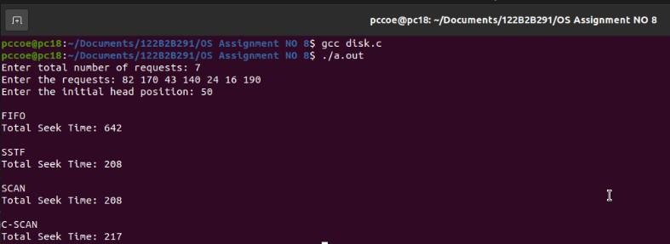**Output:**